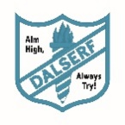
Dalserf Primary School
Summary of Standards and Quality Report 2024-2025

SLC Priority 1 – Literacy  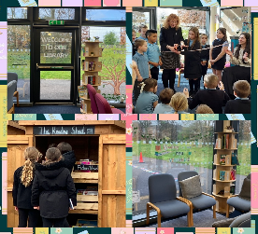 | SLC Priority 2 - Numeracy  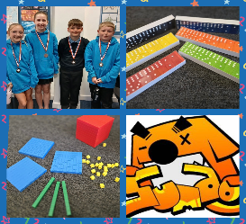 | SLC Priority 3 - Health & Wellbeing  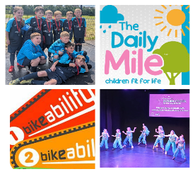 | 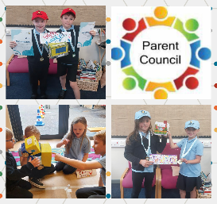  SLC Priority 4 – Science/Stem
- All staff met and worked collaboratively with Craigbank PS colleagues within the Larkhall Learning Community to moderate writing. All staff benefitted from the experience which gave them a chance to network with other colleagues out with the school.  - All staff trained by SLC in Read & Write digital programme to support children with difficulties in writing.  - Flipp is now implemented annually to the early years classes due to its success. Literacy levels in P1 have increased by 8%.  - Submission of Silver Reading  Award application in June 2025. A new library was set up with a lender borrower system and outdoor Reading Shed for classes to access new fiction and non-fiction books.  - Pupils engaged in a ‘Book Bistro’ Masterclass to encourage reading for pleasure.  - Our attainment in writing has increased in Writing to 85% in stages P1, P4 and P7. This means that most pupils in P1,P4 and P7 have achieved their expected level. | - The majority of staff have completed Maths Recovery ‘Developing Number Knowledge’ training offered by CQIS. Two staff members will undertake the training in 2025-2026.  - The Numeracy Lead has been trained in ‘You, Me Multiply’ to support parents at home with their child’s learning.  - Sumdog was purchased and has benefitted all learners including those with additional support needs as staff can set differentiated lessons to suit the learner using the digital resource.  - All staff use digital technology to enhance the delivery of numeracy and maths in the classroom.  - Our P7 team came 3rd Place in Larkhall Academy Inter-schools Maths Challenge.  - Our attainment in numeracy this session was 81% in stages P1, P4 and P7. This means that most  pupils in P1,P4 and P7 have achieved their expected level. | - All staff have completed Attachment-Informed training.  - A New Nurture room has been set up and being utilized by staff to support pupils.  - We continued to raise awareness of UNCRC Rights having gained our Bronze Award last session.  - We participated in the Peer Review process with Coulter/Lamington and St. Louise Primaries to improve wellbeing and relationships.  - P6/7 pupils led lunchtime clubs in football and dance and dancers in the annual Dance Festival.  - P7’s visited Sport Scotland, Inverclyde for their residential.  - A Muga timetable for P4-7 was created for football while Multi-sports was offered to P1-3 from Active Schools.  - Most of P5-7 took part in the inter-schools football festivals and were the Popinjay Cup winners for the 3rd year.  - All P6 pupils completed their swimming block and participated in netball and athletics taster sessions.  - A few P6 pupils achieved their Level 2 Bikeability training.  - All classes took part in the Daily Mile UK, walking, jogging or running 15 minutes each day.  - We updated our Cost of the school day policy.  - There was zero cost to parents/carers for trips.  - Most pupils participated in the Sustrans Big walk wheel initiative. A few pupils did park and stride. | - All staff used SLC Science, Stem and Technologies progression pathways and included them in their forward plans  - Our Stem lead carried out a Staff evaluation then created an action plan for Year 2 and Stem nation awards.  - Primary 7 pupils attended a British Army Stem Day organised by ‘Developing the Young Workforce.’  - A member of our Parent Council who works for Scottish Water delivered a workshop on water to P1-4.  - Stem boxes with resources were purchased courtesy of the Parent Council.  - Stem Masterclasses were undertaken by P4-7 pupils.  - Most pupils were able to transfer their skills and apply prior knowledge to Stem in a context.

