Room 1- P1/2
Term 1 August-October 2025
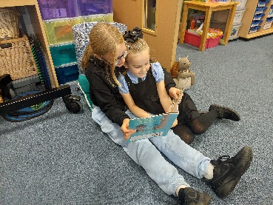
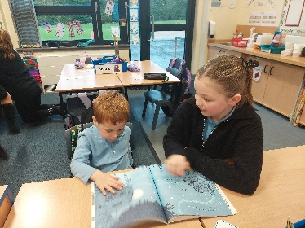
Literacy
We have been learning how to use our sounds to help us as we read.
We read with our P6 and P7 Buddies to share stories and ask questions about the books.
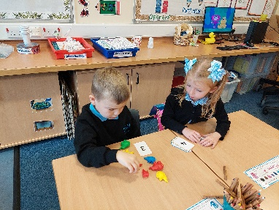
Numeracy
P1 have been learning how to recognise and write numbers to 10.
P2 have been learning numbers before and after to 30.

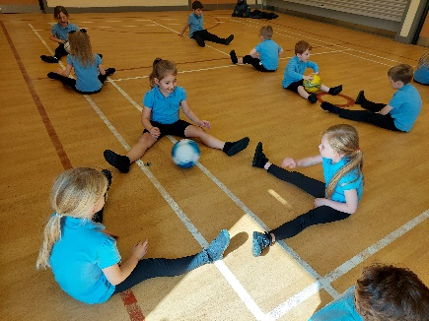
Health & Wellbeing
In PE we have been improving our Core Skills by throwing, catching and passing.
We use large balls to show our awareness of the space around us and we love the Under Over game!

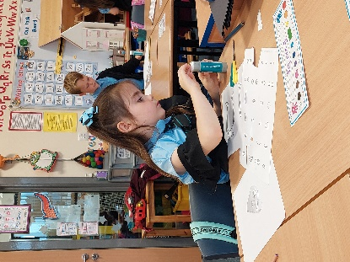
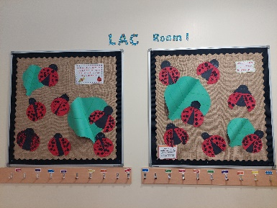
Learning Across the Curriculum
We have been exploring characters in stories and nursery rhymes.
We created our own ladybirds using our printing and cutting skills.
