**Room 1- P1/2**

**Term 1 August - October 2024**

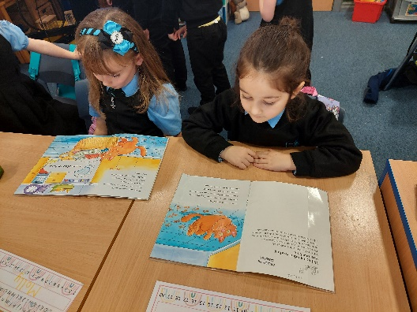

**Literacy**

We have been learning how to use our sounds to help us as we read and write.

We read with our Room 4 Buddies every week to share stories and practise our books.

**Numeracy**

P1 have been learning how to recognise and write numbers to 10.

P2 have been learning numbers before and after to 100!

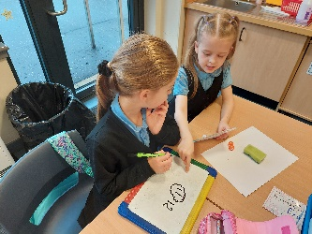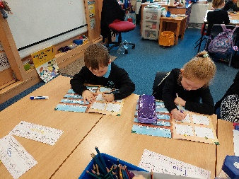

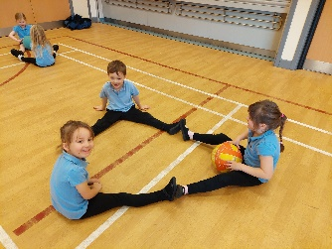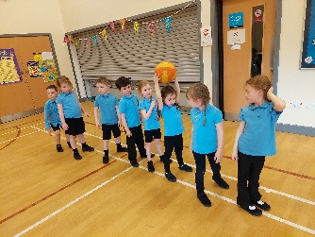

**Health & Wellbeing**

In PE we have been improving our Core Skills by throwing, catching and passing a large ball with our hands and feet.

We love to play the Under Over game and get very exited cheering on our friends.

**Learning Across the Curriculum**

We have been exploring the seasons and investigating Autumn.

We created our own hedgehogs using forks to print the spines and made trees using corks to print the colourful leaves.

