Room 1- P1/2
Term 1 October- December 2025

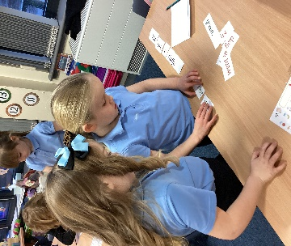
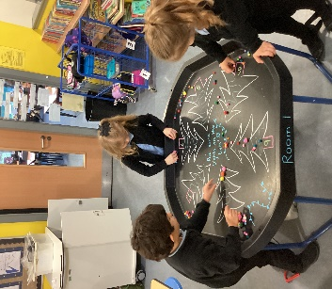
Literacy - We have been improving our writing by creating expanded sentences and using the connective ‘and’.
We have been using our listening skills to help us ask questions about the story we are listening to.
Numeracy
P1 have been ordering numbers to 10 and have begun to add to 10.
P2 have been ordering numbers to 30 and have been adding to 20.
All the children have been working with shapes and learning to measure.
Health & Wellbeing
In PE we have been learning Scottish dances. We have been practising our steps and formations during the Military Two Step.
In Health we have been learning about germs and the importance of good hygiene.
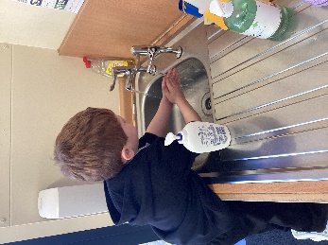

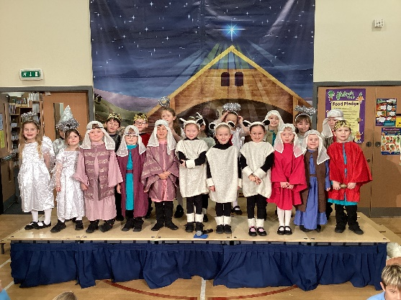
Learning Across the Curriculum
We have learned about Harvest and what foods grow in Scotland.
We have practised very hard to learn our lines and songs for our Nativity “It’s a Baby”.

Everyone in Room 1 would like to wish you a very Merry Christmas and a very safe and happy New Year!

