Room 1- P1/2
Term 4 April- June 2026
Literacy –
We have worked very hard to learn our sounds- P1 know all their single sounds so have moved on to blends. P2 are working very hard to use their sounds when reading new words.
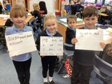

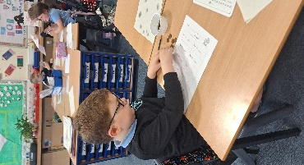
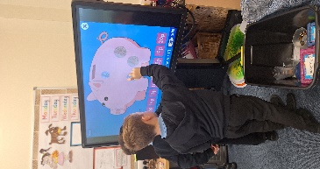
Numeracy
P1 have been reading, writing and counting to 20.
P2 have been learning to multiply and divide.
All the children have been working with coins and notes; making amounts and working out change.
Health & Wellbeing
We tried hard in our preparation for Sports Day. We were great at our races and particularly enjoyed the egg and spoon race!
Learning Across the Curriculum
We went on a Farm Park trip to consolidate our learning about farming in Scotland. We saw sheep, chickens, horses and got to feed the goats!
It was the best day!


