Room 2 – P3/4
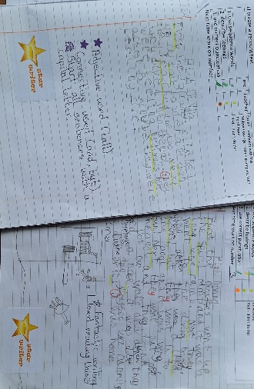
Term 1 August - October 2026
Literacy
Our writing focus has been on recount texts and we are becoming experts using sequence words. We have also been learning how to create a writing plan and then use this to organise our writing.
Each week star writers are chosen and their work is shared and displayed in class.
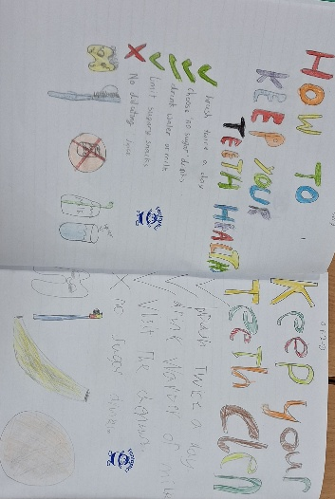
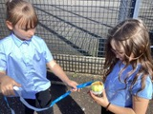
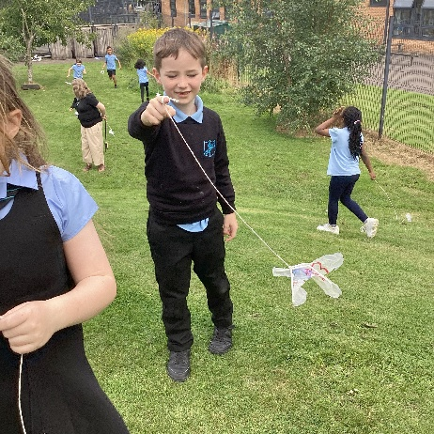
HWB
We have been looking at ways to look after our teeth and created posters to give tooth care advice. We have also been thinking about the different food groups we need to eat to keep our bodies healthy.
Numeracy and Mathematics
We have been focussed on number sequences and place value and using a variety of concrete materials and pictures to help us. We have also been using rulers, metre sticks and measuring tapes to measure accurately.
Learning Across the Curriculum
At the start of the term we read the book Flat Stanley together. We used this as a springboard for lots of different activities, including writing, Art and technology. We enjoyed taking our own ‘Stanleys’ home for an adventure and making Stanley kites to fly in the garden.

