Room 2-P3/4
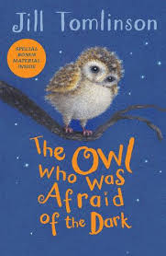
Term 1 August-October 2025
Literacy
In P3/4 we have been reading ‘The Owl Who was Afraid of the Dark’. We have enjoyed finding out why Plop does not like the dark. We re-created our own version of the story in writing with different animals.

Numeracy
In Numeracy, we have been learning all about Place Value. We have enjoyed exploring what the value of a number is through games and concrete materials.
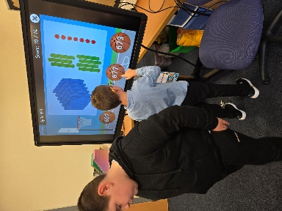
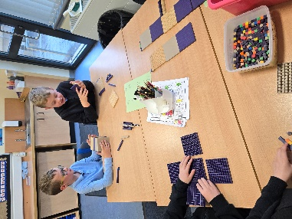
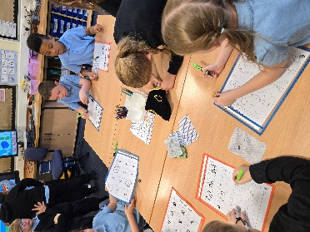

Health & Wellbeing
In PE, we have been looking at Ball Skills and have been improving our throwing, catching and passing. We also loved learning some Kick-Boxing when Rivals Gym came in!!
In Health and Wellbeing, we have also been discussing what makes a good friend and have enjoyed learning each other’s likes and dislikes.

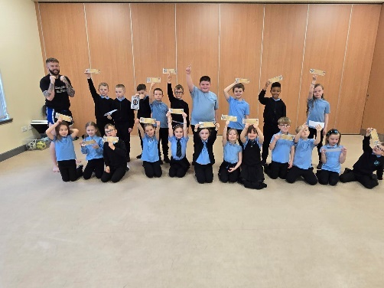

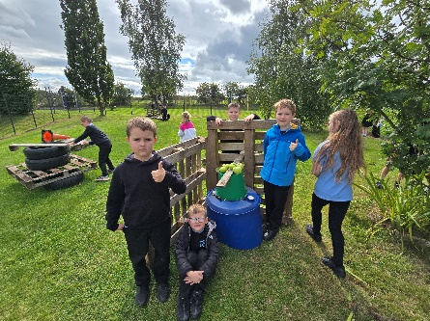
Learning Across the Curriculum
We have been exploring animal habitats of nocturnal animals and created some of our own during Outdoor Learning.
In science, we have been learning about water. We learned about the Water Cycle and enjoyed different experiments around dissolving and melting.
