Room 2 - P3/4
Term 2 October-December 2025
Literacy
In P3/4, we have been developing our writing skills. We have been looking at fragmented and scrambled sentences and developing the skill of reading over a sentence to make sure it makes sense and correcting it if it does not!

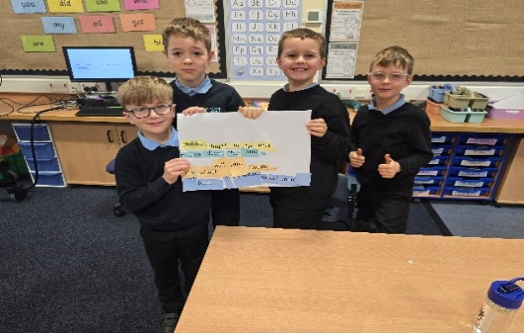


Numeracy
In Numeracy, we have been working on addition and money. We created a shop in the classroom and have been working on adding different amounts up and challenging ourselves to work out the amount of change we would need.
Room 2 also really enjoyed participating in the SLC Sumdog Contest!

Health & Wellbeing
In PE, we have been looking at racket skills and have been working on serving to a partner. We also teamed up with Room 1 to do some Scottish Country Dancing!
In Health and Wellbeing, we created a poster on how to support and prevent Cyber Bullying as part of Anti-Bullying Week!

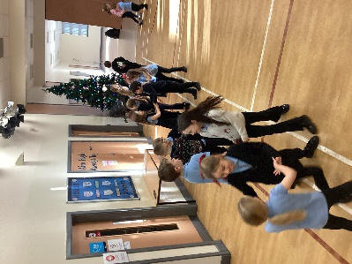
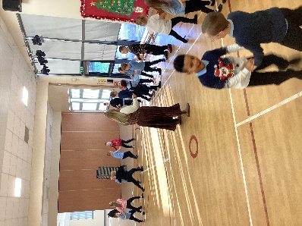

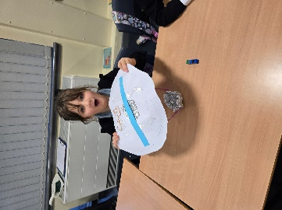
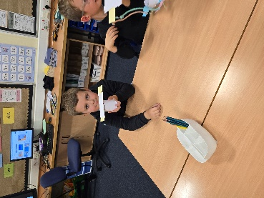
Learning Across the Curriculum
We used problem solving and team work to create a device that Plop the Owl (from The Owl Who Was Afraid of the Dark) could use to help him land on the ground as he had a habit of falling over. We enjoyed using different materials to create these!

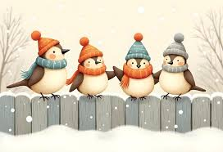
From everyone in Room 2, we wish you a very Merry Christmas and a Happy New Year.

