Room 2 - P3/4
Term 4 April to June 2026
Literacy
In P3/4, as part of our Ancient Egyptians topic, we created some wonderful imaginative stories set in the pyramids and meeting a Pharoh. We used exciting adjectives to describe what we could see and feel.
The class also thoroughly enjoyed writing instructions all about our how to mummify a body!

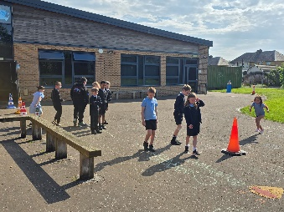
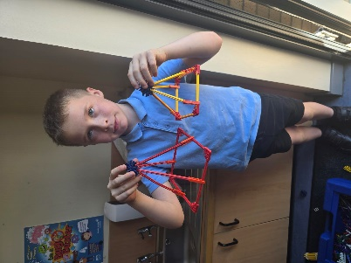
Numeracy
In Numeracy, we have been learning all about time! We have been learning all about digital and analogue times and have enjoyed using the analogue clocks to help us.
We have also been looking at measure and have enjoyed going outside to measure different parts of the school using different materials.
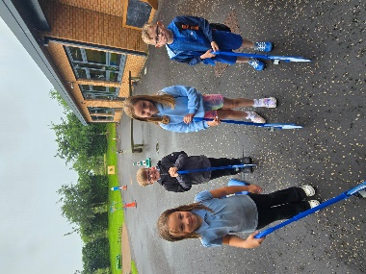

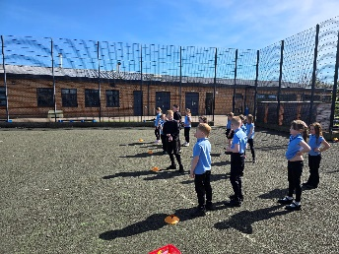
Health & Wellbeing
In PE, we have been learning all about orienteering and have enjoyed the challenges set by Mrs Kelly-Kerr!
We also enjoyed participating in Sports Day and enjoyed our ice-cream afterwards.
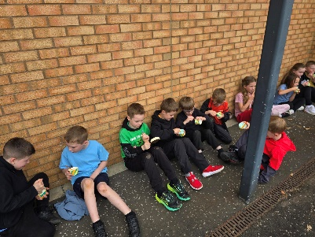

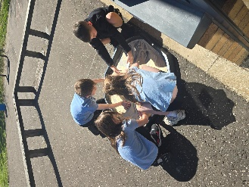
Learning Across the Curriculum
We have absolutely loved learning about Ancient Egypt this term! We have had the opportunity to create some fabulous pieces of art using different materials such as oil pastels, painting and paper to create collages. We have learned and developed different artistic skills such as blending and shading to create effective art pieces.



