Room 3 – P5/6
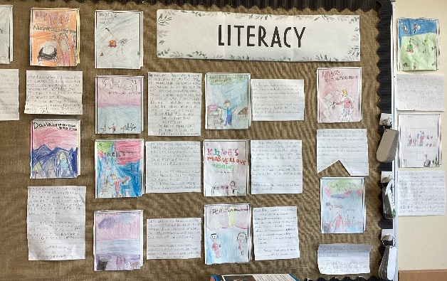
Term 1 August - October 2026
Literacy
Room 3 have been reading George’s Marvellous Medicine. We made predictions based on the title, cover page, blurb and what we already know about Roald Dahl books. We created front covers and blurbs for some of our own creative potions!

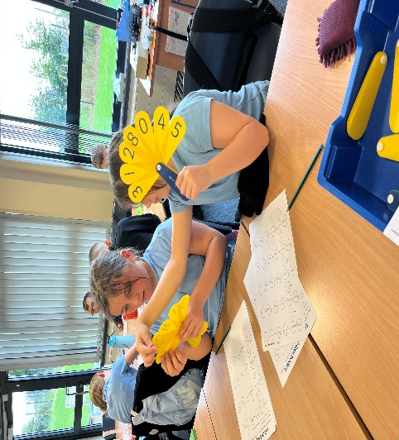
Numeracy
We have been learning about the value of each digit in 6-digit numbers. We have practised reading them, breaking them up and making them when someone creates clues to a number. We can order these and round them to the nearest 10, 100 and 1000.

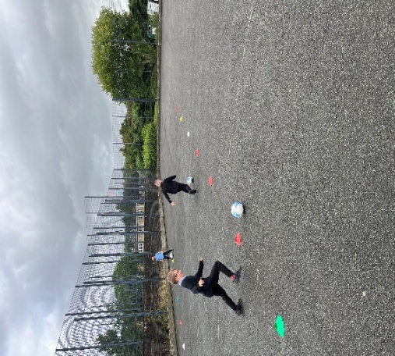
Health & Wellbeing
In PE we have been developing our ball skills. In football we have been challenging ourselves in dribbling around static objects and then to include a moving defender. Our control of the ball is growing every week. We have been concentrating on positions and keeping to these when we are in a game.

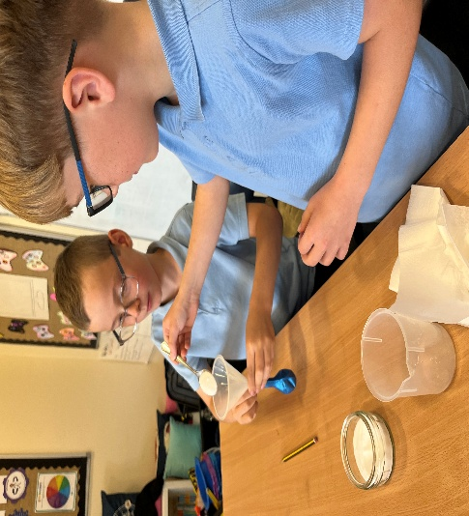
Learning Across the Curriculum
Room 3 has been turned into a science lab for 1 afternoon a week. We have been exploring scientific vocabulary, making predictions, carrying out experiments, observing and recording chemical reactions. The children are working well together to make sure everyone is involved and safe during our experiments.

