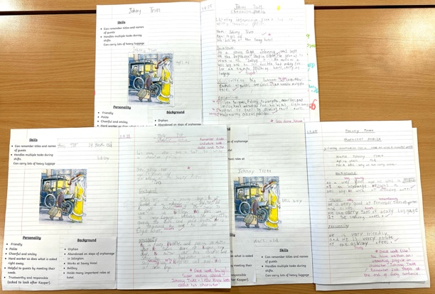
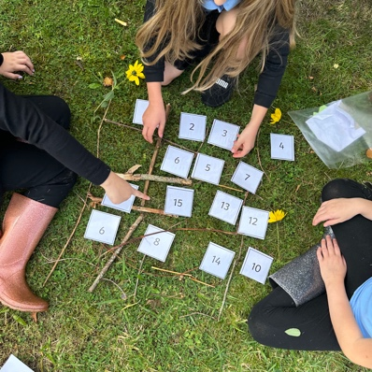
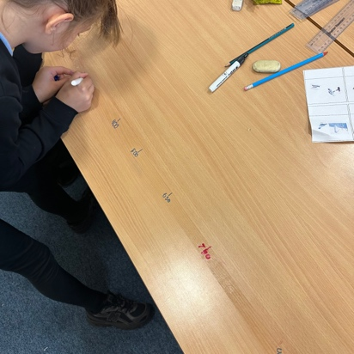
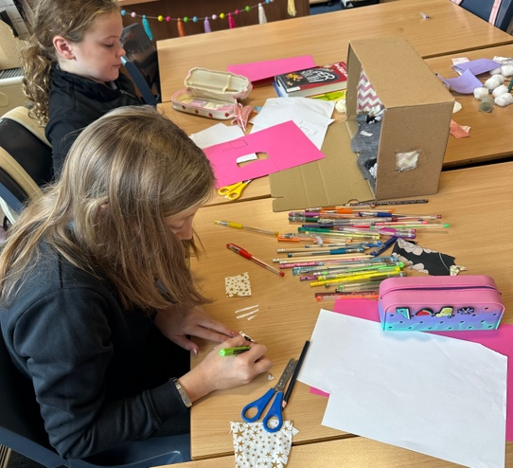
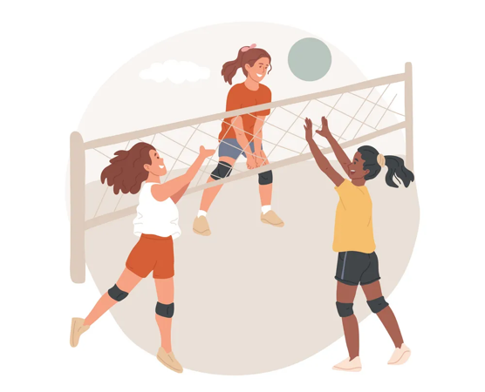
Learning Across the Curriculum
This term we have loved learning all about the Titanic! As part of our topic, we followed a design brief to produce a 3D model of 1st, 2nd or 3rd class passenger cabins. We used a variety of materials to bring our cabin to life!
Numeracy and Mathematics
We have been focusing on number, place value, rounding and 2D shapes this term. We have enjoyed doing lots of active activities during our lessons. During outdoor learning, we applied our number knowledge to play games including ‘Slide Fifteen’!
Literacy
For our class novel, we have been reading Kaspar Prince of Cats by Micheal Murpurgo. This links with our Titanic topic as we have read all about the adventures of Johnny Trott and Kaspar on board the unsinkable ship…! We even wrote character profiles about Johnny Trott.
Health and Wellbeing
During indoor P.E. the Primary 5’s have been developing their volleyball skills and enjoying participating in short games. Meanwhile, the Primary 6’s have been loving their swimming visits to the local leisure centre! For outdoor P.E. this term, we have all been focusing on our football skills.
Room 3–P5/6
Term 1 August–October 2025

