Room 4 – Primary 6/7
Term 1 August – October 2026
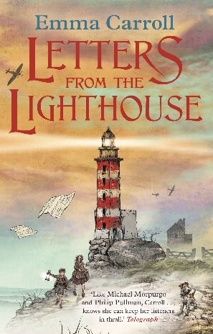
Literacy
We have been enjoying our class novel Letters from the Lighthouse, linked to our WW2 topic. We have developed key reading skills such as visualising and summarising and have written a postcard from a character’s point of view. We are looking forward to finding out how the story ends!

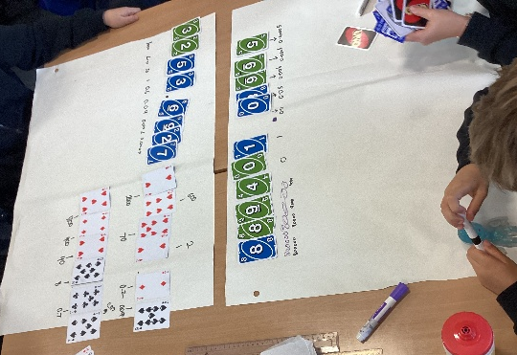
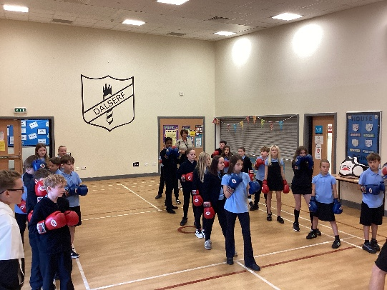
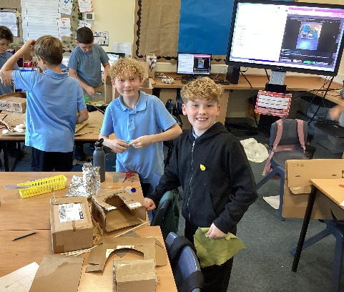
Health & Wellbeing
Primary 6 have been enjoying swimming and developing their skills. Primary 7 have been enjoying rugby, further developing their ball skills through passing, catching and teamwork. We also had lots of fun at our boxing taster with Law Boxing Club!
Interdisciplinary Learning
As part of our World War II topic, we have been learning about air raid shelters and how they were used to keep people safe. We enjoyed designing and making our own air raid shelters, thinking carefully about how they could protect people during air raids.
Maths & Numeracy
We have been developing our understanding of place value, including partitioning and working with decimals. We have also been revising our knowledge of shape and rounding and look forward to building on our learning through lots of fun activities!

