Room 4–P6/7
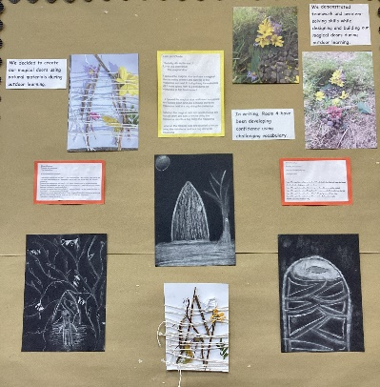
Term 1 August–October 2025
Literacy
In writing we have been developing our knowledge of how to use challenging and interesting vocabulary to engage our reader and make our writing more detailed. We wrote about magical doors and decided to create some outdoor artwork linked to our writing. We are also learning to describe characters and have enjoyed describing well known villains from children’s films/books.

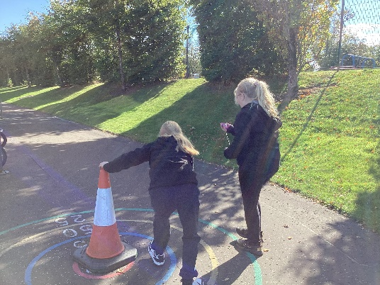
Numeracy
We have been learning about time intervals and have been developing our understanding of how time is used in real life, including bus and train timetables. We also used stopwatches to time us doing different skills such as running and star jumps.

Health & Wellbeing
We have been developing our teamwork and ball skills while playing netball in PE. We understand the different rules and positions, and we are learning to work together to play mini netball games. We enjoyed our opportunity to trial a martial arts class when Rivals visited. We learned about showing respect and started to learn some kickboxing techniques. The pad work was a strong favourite.
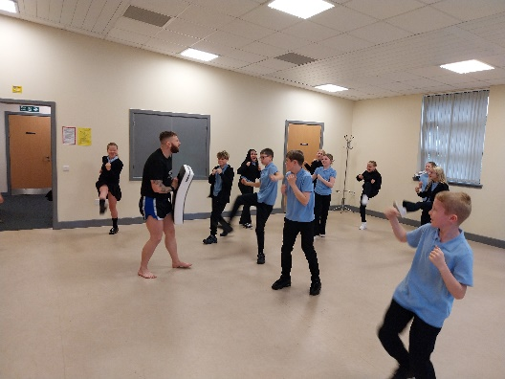

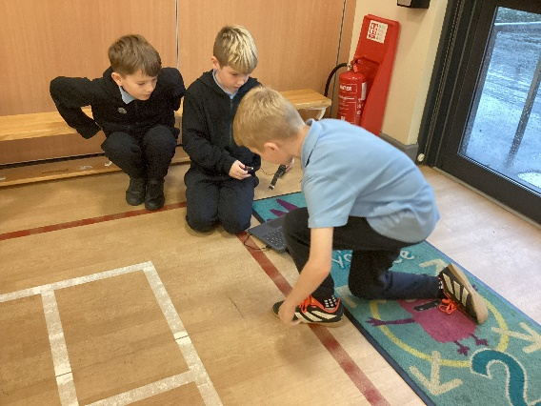
Learning Across the Curriculum
We have been learning to programme micro: bits to measure how much power is in each kick of a ball/swing of a bat.
We have developed our understanding of sports science and can explain why this information is important to athletes.

