**Room 1- P1/2**

**Term 4 April- June 2025**

**Literacy –**

We have worked very hard to learn our sounds- P1 know all their single sounds so have moved on to blends. P2 are working very hard to use their sounds when reading new words.

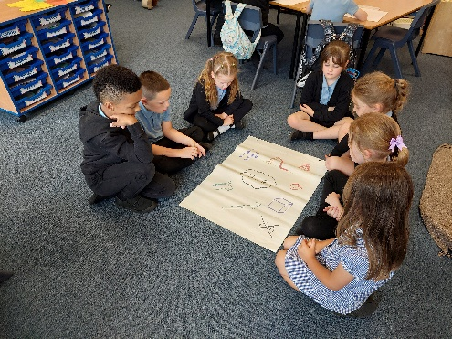

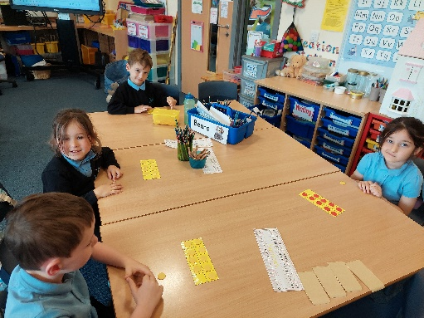

**Numeracy**

P1 have been adding to 20 and telling o’clock on digital and analogue clocks.

P2 have been learning to divide and telling half past on digital and analogue clocks.

All the children have been learning about ordinal numbers- we like being 1st but not 2nd or 3rd 😊!

**Health & Wellbeing**

We tried hard in our preparation for Sports Day. We were great at our races and particularly enjoyed the egg and spoon race!

**Learning Across the Curriculum**

We went on a Transport Museum Trip to consolidate our learning about transport in the past. We saw trams, a subway train, boats, cars and motorbikes.

It was the best day!

