**Room 3 – P4/5**

**Term 2 October - December 2023**

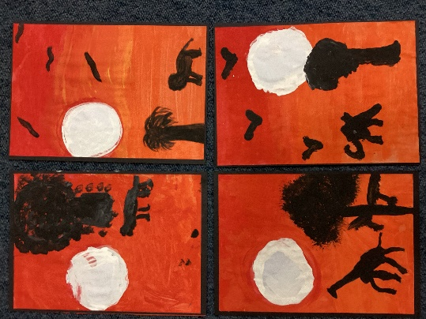

**Literacy**

Within writing we have been developing our confidence when writing instructions for a variety of tasks which we have undertaken within school. This has included how to create a sunset picture and how to makes smores.

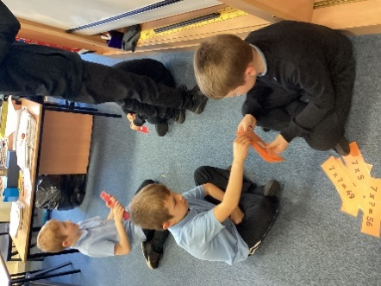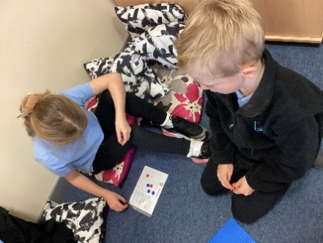

**Numeracy**

We have been developing our knowledge and confidence with multiplication through a variety of games, ICT and active learning activities. We have also explored written methods of multiplication.

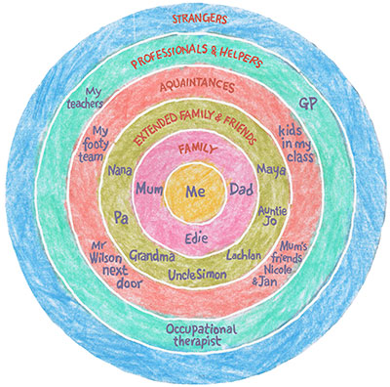

**Health & Wellbeing**

In Health and Wellbeing we have been considering aspects of friendship and identifying our circle of support, such as close family and friends, extended family, acquaintances and professionals who help us.

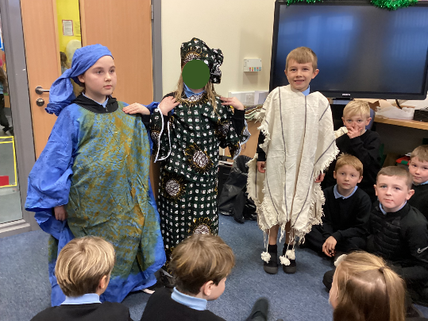

**Learning Across the Curriculum**

Through the topic of Africa we have developed our mapping skills and sense of place within the world. We have also developed a range of Art and Design skills.

We enjoyed trying on West African clothes and creating our own clothing designs.